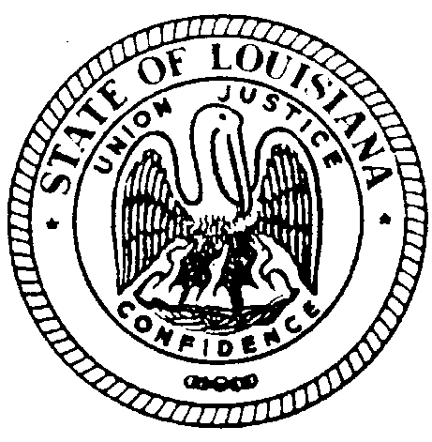

STATE OF LOUISIANA
LOUISIANA BOARD FOR HEARING AID DEALERS
308 Gregory Dr. Luling, LA 70070 E-Mail- labhad@la.gov Voice/Text: (504) 655-0383

BOARD MEETING

DATE: Friday July 29, 2022

TIME: 1:00PM-4:30PM (tentative end time)

LOCATION: Embassy Suites
4914 Constitution Ave.
Baton Rouge, LA 70808

This meeting is open to the public.

Submitted on behalf of The Louisiana State Board for Hearing Aid Dealers by:

Dina Zeevi
Administrative Secretary
Louisiana Board for Hearing Aid Dealers
(504)655-0383
labhad@la.gov

State of Louisiana
THE LOUISIANA BOARD FOR HEARING AID DEALERS

Lakeway Marriott 3838 N. Causeway Blvd. Metairie, LA 70002
Friday July 29, 2022

AGENDA

- CALL TO ORDER – Roll Call-Establish Quorum

Public Comments

- APPROVAL OF AGENDA

- READING/APPROVAL OF MINUTES – January 22, 2022

- SECRETARY/TREASURER’S REPORT
- Review 2021-2022 Final Budget
- Present 2022-2023 Projected Budget

- COMMITTEE REPORTS
- Ethics Committee-Bryan Stinson
#119 3/22 Cash VS. Miracle Ear/J. Stuart
- Examination Committee-Bryan Stinson
- Legislative Committee- Jeremy Stroud

- UNFINISHED BUSINESS

- NEW BUSINESS
- CEs all online 2022
- CE credit for required state classes for Board Members
- CE credit for proctoring Practical Exam
- ByLaws Article IX Representative of Ethics Committee
- ByLaws Article VI RETAKE language for Written Examination
- Application- Submit License Verification #13, add Board Mailing Address, make check payable information, Revise fee wording(clerical-Board Approval requested)
- Authorize Virtual Office Inspection
- Elderly Consumer- Revise language

DATE AND LOCATION OF NEXT 2023 MEETING/PRACTICAL EXAMINATION

ADJOURNMENT

